**COMPUTER NETWORKS LAB – EXPERIMENTS**

1. Configuration of Network Devices using Packet Tracer (Hub, Switch, Ethernet, Broadcast)

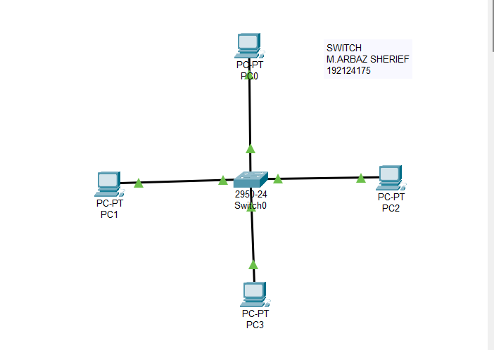

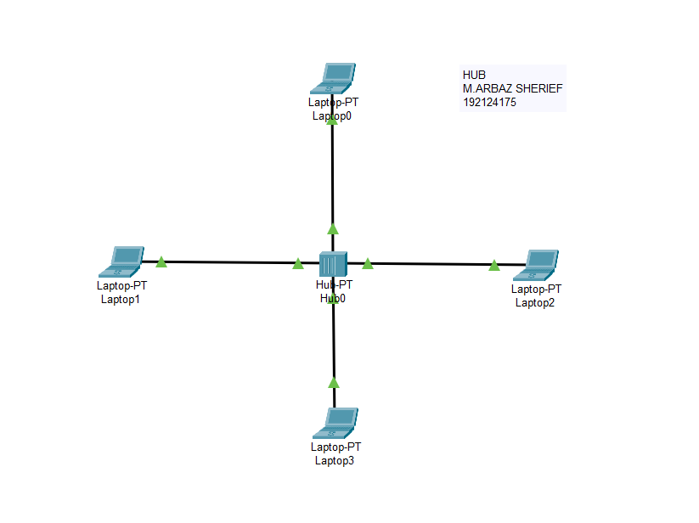

1. Configuration of Topologies using Packet Tracer (Star, Mesh, Tree,)

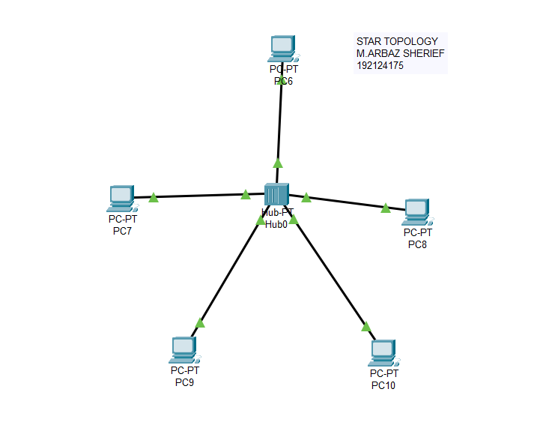

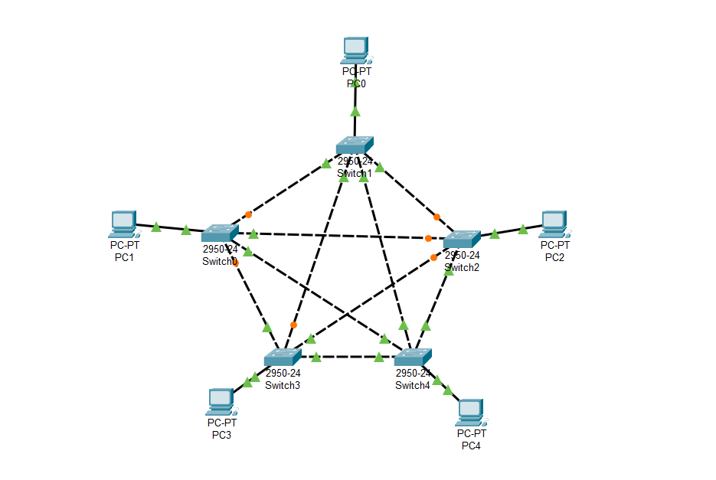

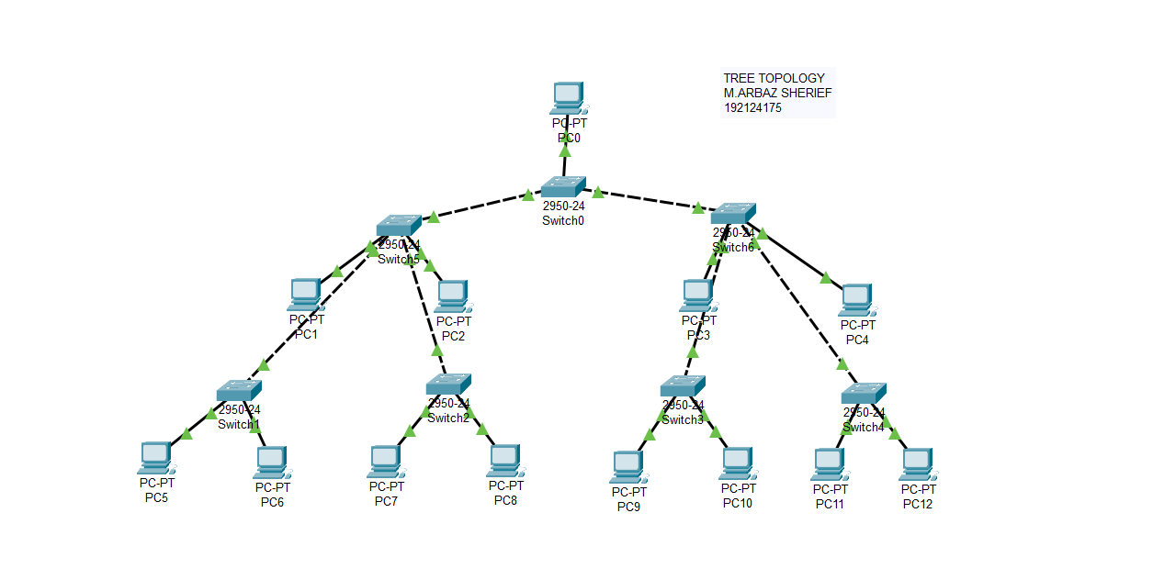

1. Configuration of Topologies using Packet Tracer (Bus, Ring, Hybrid)

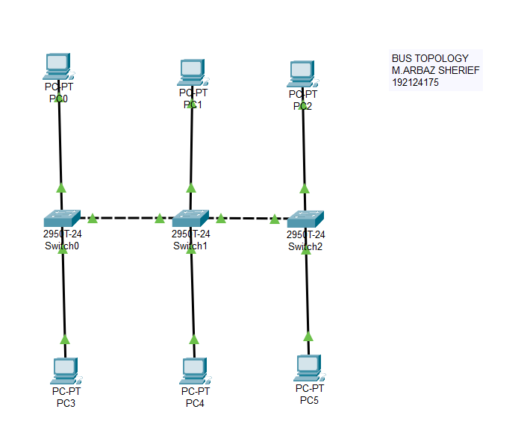

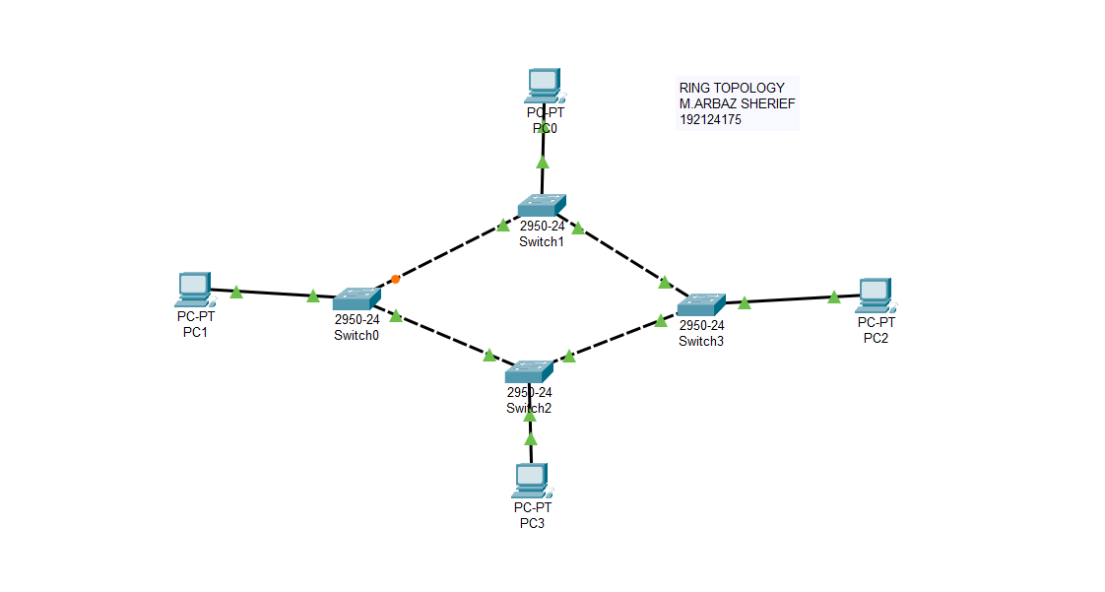

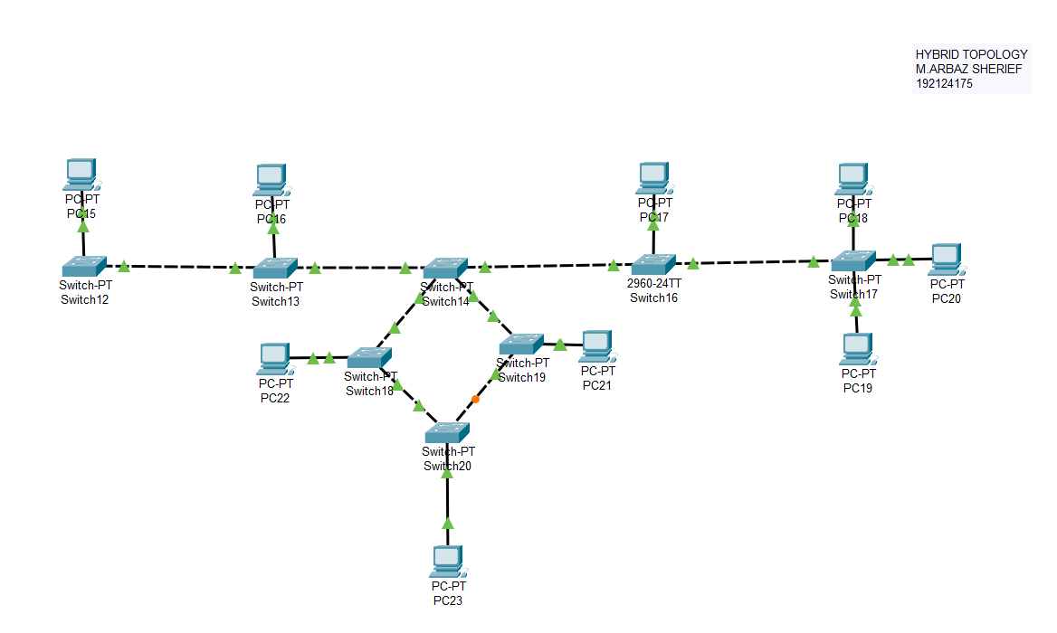

1. Data Link Layer Traffic Simulation using Packet Tracer Analysis of CSMA/CD& CSMA/CA

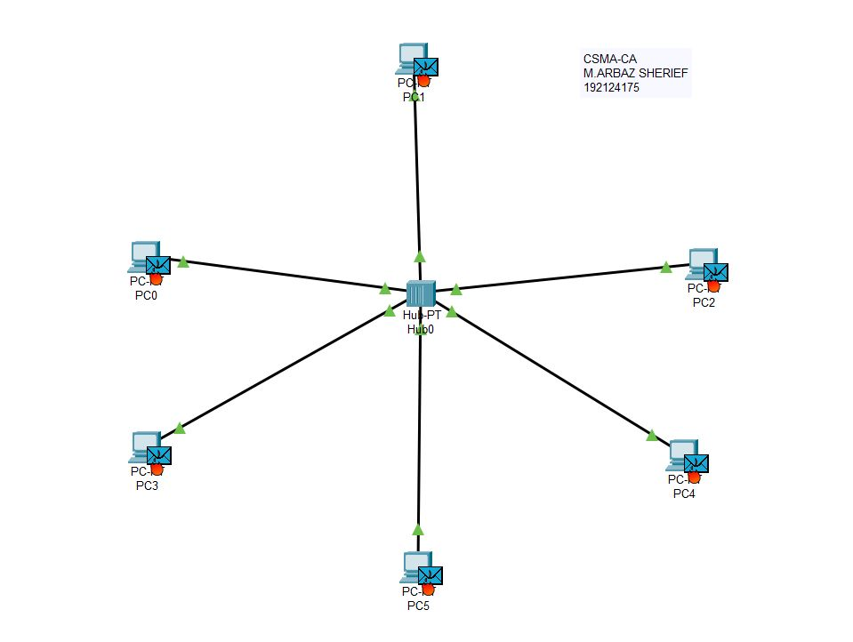

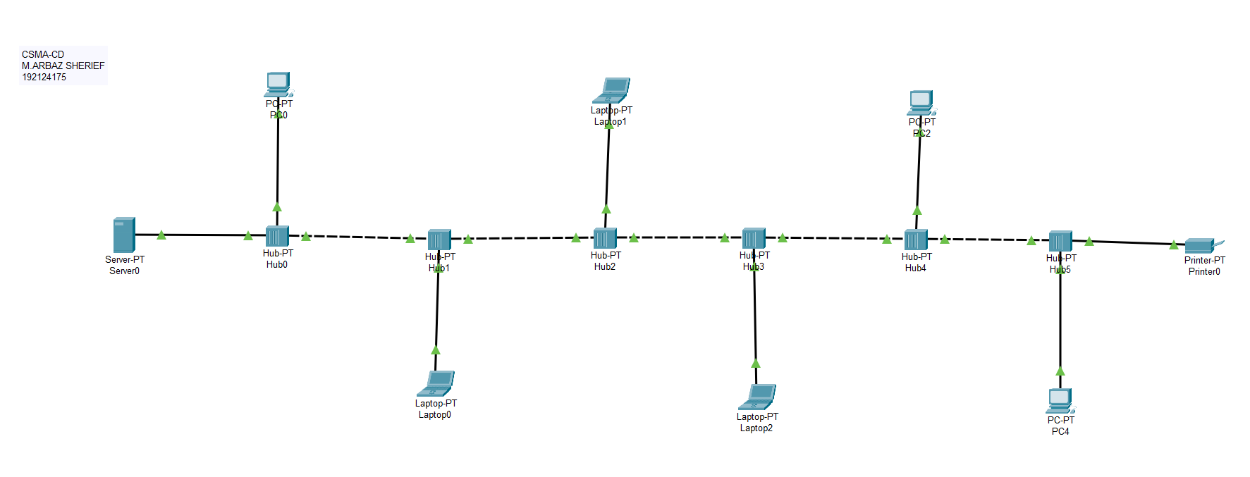

1. Data Link Layer Traffic Simulation using Packet Tracer Analysis of ARP

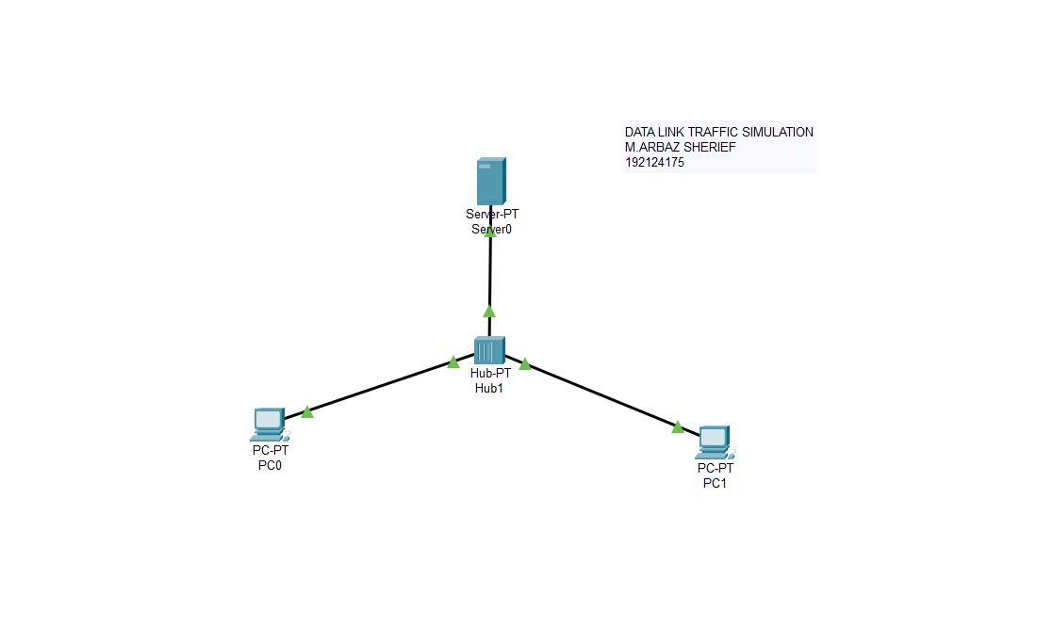

1. Static Routing using Packet Tracer

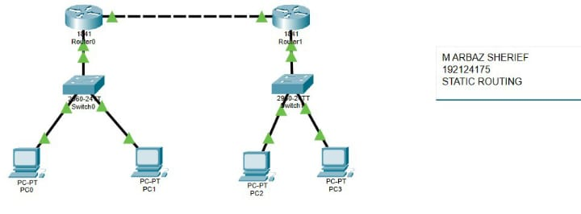

1. Dynamic Routing using Packet Tracer ( OSPF)

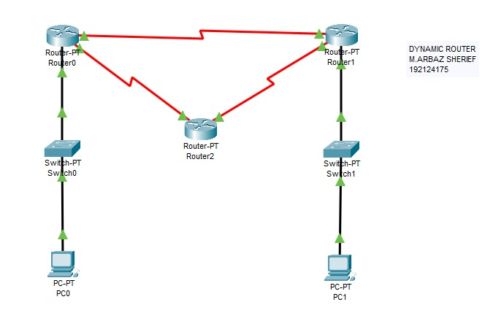

1. Subnetting – Class C Addressing

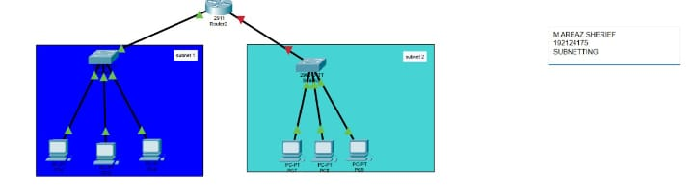

1. Functionalities of TCP, UDP

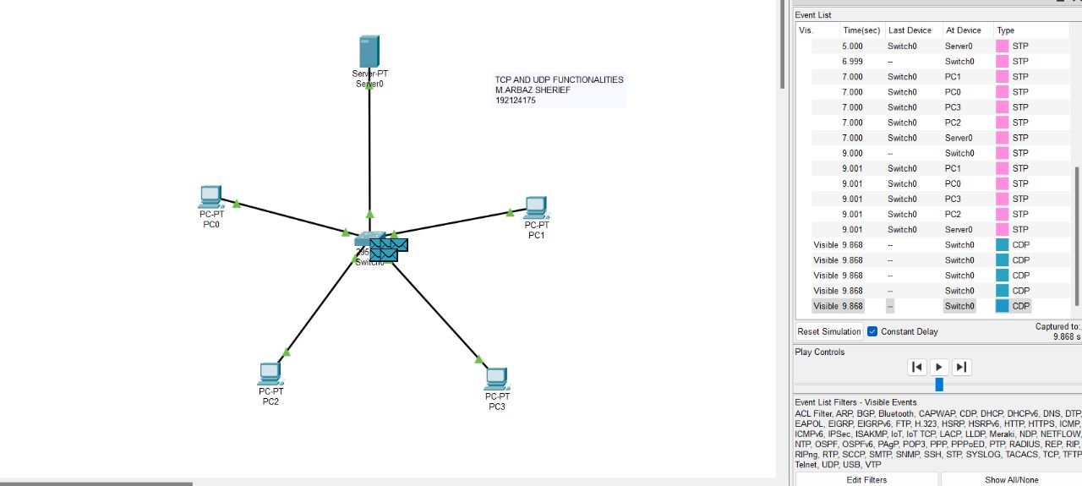

1. TCP, UDP Exploration Solution

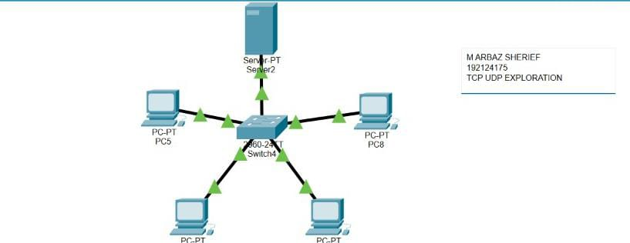

1. IOT Based Smart Home Using Cisco Packet Tracer

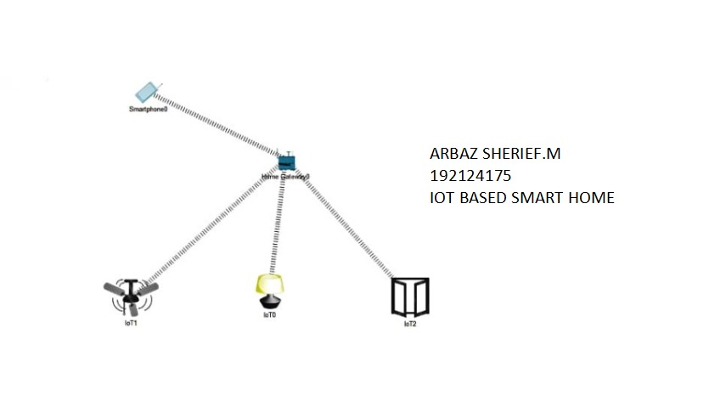

1. Smart Garden in Cisco Packet Tracer

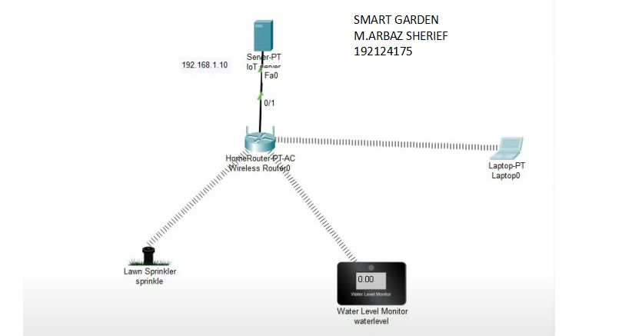

1. IOT Devices in Networking Using Cisco Packet Tracer



1. Simulating X,Y,Z Company Network Design

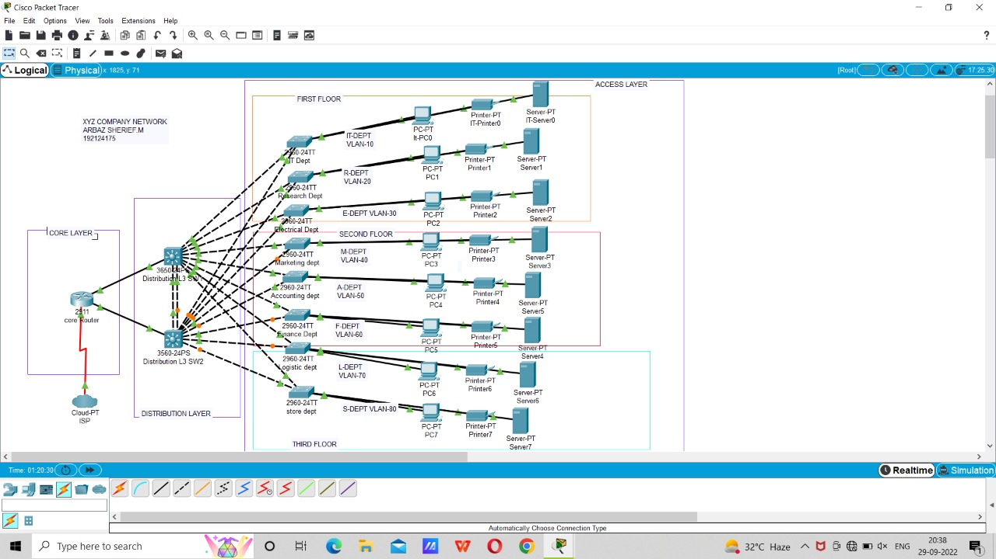

1. Make Computer Lab in Cisco Packet Tracer

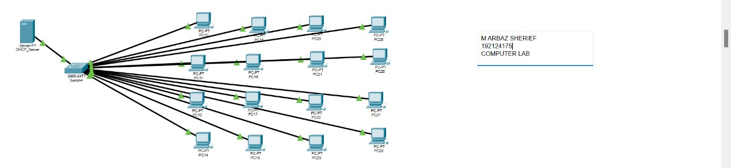

1. Simulate a Multimedia Network

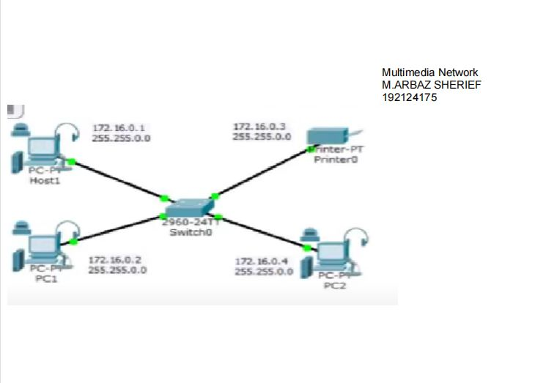

1. AAA Local & Server Based Authentication Configuration in Cisco Packet Tracer

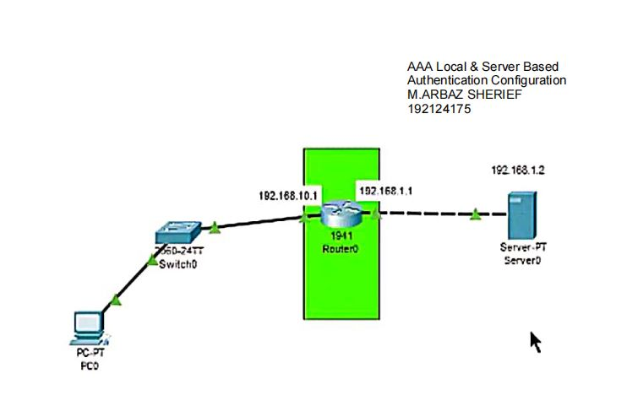

1. IOT Based Smart Home using WPA Security & Radius Server

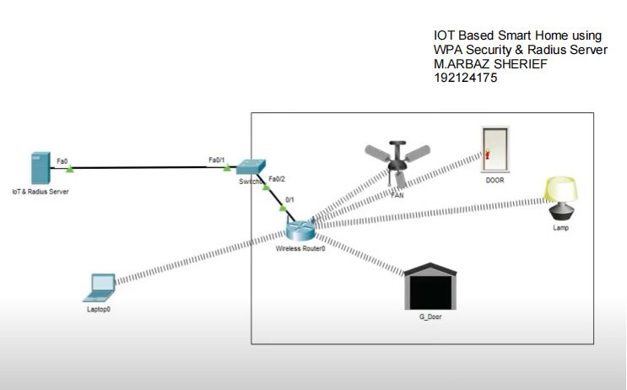

1. WLAN Using Cisco Packet Tracer

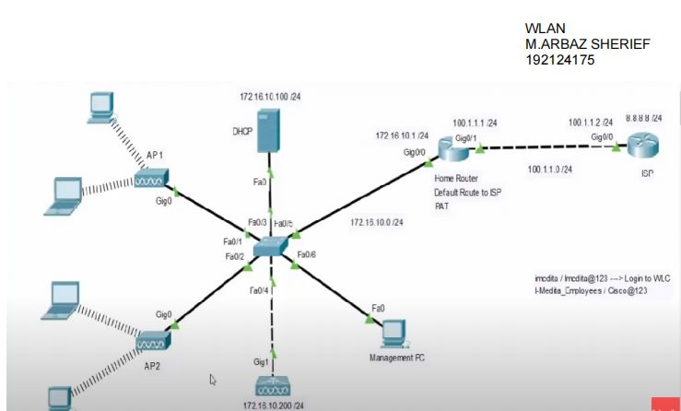

1. Control of Fan, Light, Window & Application of Using Cisco Packet Tracer

